**Abstract:**

A diode rectifies an ac voltage, so that it can be smoothed and converted into a dc voltage. A rectifier, however, can produce a constant or variable DC voltage. A diode rectifier can produce a fixed DC voltage whereas an SCR can produce a variable DC voltage.

**Introduction:**

The objectives of this lab are to:

1. study Half wave rectifiers,
2. study Full wave rectifiers.

**Theory and Methodology:**

Diode rectifiers are of the following types:

1. Half-wave rectifier.
2. Full-wave bridge rectifier.
3. Center tapped Full-wave rectifier.

A rectifier, however, cannot produce a smooth DC voltage. So the rectification block that makes the output DC voltage a smooth one follows a filter circuit. In this case, the capacitor acts as a smoothing filter so that the output is nearly a dc voltage. A filtering is not perfect; there will be a remaining voltage fluctuation known as ripple, on the output voltage.

The half-wave voltage signal is normally established by a network with a single diode has an average or equivalent DC voltage level equal to 31.8% of the peak voltage, whereas the full-wave rectified signal has twice the average or DC level of the half-wave signal, or 63.6% of the peak value.

**Working Principle of Half-wave rectifier:**

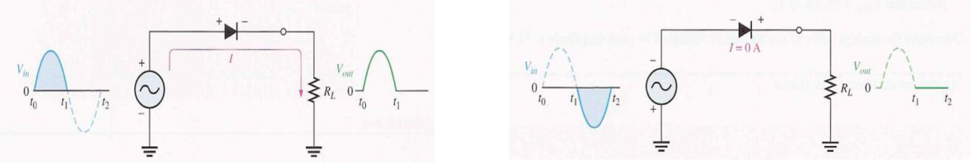In half wave rectifier only half cycle of applied AC voltage is used. Another half cycle of AC voltage (negative cycle) is not used. Only one diode is used which conducts during positive cycle. The circuit diagram of half wave rectifier without capacitor is shown in the following figure.

**Figure-1**: Half-Wave Rectification

During positive half cycle of the input voltage anode of the diode is positive compared with the cathode. Diode is in forward bias and current passes through the diode and positive cycle develops across the load resistance RL. During negative half cycle of input voltage, anode is negative with respected to cathode and diode is in reverse bias. No current passes through the diode hence output voltage is zero.

**Working Principle of Full-Wave rectifier:**

The Bridge rectifier is a circuit, which converts an ac voltage to dc voltage using both half cycles of the input ac voltage. The Bridge rectifier circuit is shown in the following figure.

The circuit has four diodes connected to form a bridge. The ac input voltage is applied to the diagonally opposite ends of the bridge. The load resistance is connected between the other two ends of the bridge. For

the positive half cycle of the input ac voltage, diodes D1 and D2 conduct, whereas diodes D3 and D4 remain in the OFF state. The conducting diodes will be in series with the load resistance RL and hence the load current flows through RL. For the negative half cycle of the input ac voltage, diodes D3 and D4 conduct whereas, D1 and D2 remain OFF. The conducting diodes D3 and D4 will be in series with the load resistance RL and hence the current flows through RL in the same direction as in the previous half cycle. Thus a bi-directional wave is converted into a unidirectional wave.

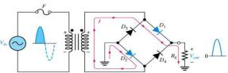

**Figure-2**: During positive half-cycle of the input, D1 and D2 are forward-biased and conduct current. D3 and D4 are reverse-biased

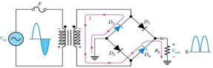

**Figure-3**: During negative half-cycle of the input, D3 and D4 are forward-biased and conduct current. D1 and D2 are reverse-biased

**Working Principle of Center Tapped Full-Wave rectifier:**

A center tapped rectifier is a type of full wave rectifier that uses two diodes connected to the secondary of a center tapped transformer, as shown in below diagram. The input voltage is coupled through the transformer to the center-tapped secondary. Half of the total secondary voltage appears between the center tap and each end of the secondary winding as shown.

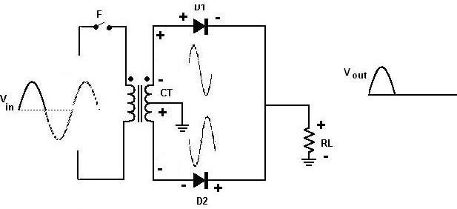

**Figure-4**: During positive half-cycle of the input, D1 is forward-biased and D2 is reverse-biased.

For a positive half cycle of the input voltage, the polarities of the secondary voltages are shown in figure. This condition forward biases diode D1 and reverse biases diode D2[.The current](http://electrapk.com/the-current/) path is through D1 and the load resistor RL.

For a negative half cycle of the input voltage, the voltage polarities on the secondary are shown. This condition reverse biases D1 and forward biases D2. [The current](http://electrapk.com/the-current/) path is through D2 and RL. Because the output current during both the positive and negative portions of the input cycle are in the same direction through the load the output voltage developed across the load resistor is a full wave rectified dc voltage.

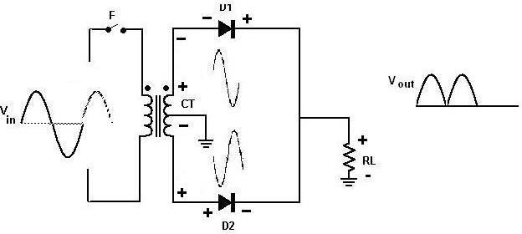

**Figure-5**: During negative half-cycle of the input, D2 is forward-biased and D1 is reverse-biased.

**Apparatus:**

|  |  |  |
| --- | --- | --- |
| **No.** | **Apparatus** | **Quantity** |
| 1 | Diode | 4 |
| 2 | 10k Resistance | 1 |
| 3 | Project Board | 1 |
| 4 | Oscilloscope | 1 |
| 5 | Multimeter | 1 |
| 6 | Transformer 220V/12V/9V/6V | 1 |
| 7 | 47μF Capacitor | 1 |
| 8 | 100μF Capacitor | 1 |
| 9 | Chord | 2 |

**Circuit Diagram:**

|  |  |  |  |  |  |  |  |  |  |  |
| --- | --- | --- | --- | --- | --- | --- | --- | --- | --- | --- |
|  |  | D1 |  |  |  |  |  |  |  |  |
| 220V AC | 24V | R | L | C | V | o | |  |  |  |
|  |  |  |  |  |  |  |
|  | Figure 1: Half wave rectifier. | | |  |  |  |  |  |  |  |
| 220V AC | |  |  |  | R | |  | C | V |  |
|  |  |  |  |  | L | o |
|  |  |  |  |  |  |
|  |  |  |  |  |  |  |  |  |
|  | 220V/24V |  |  |  |  |  |  |  |  |  |
|  | Figure 2: Full wave Bridge rectifier. | | | | | | |  |  |  |

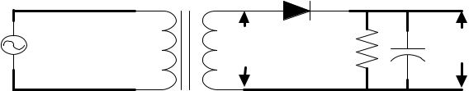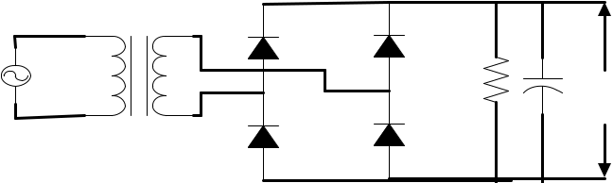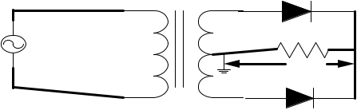

|  |  |  |  |
| --- | --- | --- | --- |
| 220V AC | R | L |  |
|  |  |
|  |  | V | o |
|  |  |  |
|  | 220V/24V |  |  |
| Figure 3: Full wave Center Tapped rectifier. | | | |